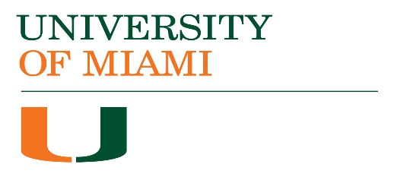 | ACADEMIC  PROGRAM ASSESSMENT PLAN  AY 2017-18 FEEDBACK

Accepted | School/College:
Needs Some Revisions | Program & Degree:
Needs Major Revisions | Contact Name(s):
Meeting Required | Email:

Mission Statement
Mission statement included

student learning outcomeS (SLOS), METHODS and results
SLOs are specific, clear, measurable, attainable
Methods clearly indicate assignment, scoring instrument, targets

Feedback:

