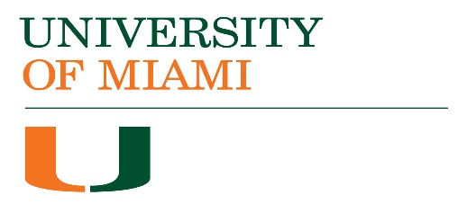 | ACADEMIC  PROGRAM ASSESSMENT REPORT  AY 2016-17 FEEDBACK

Accepted | School/College:
Needs Some Revisions | Program & Degree:
Needs Major Revisions | Contact Name(s):
Meeting Required | Email:

Mission Statement
☐ | Mission statement included

student learning outcomeS (SLOS), METHODS and results
SLOs are specific, clear, measurable, attainable
Methods clearly indicate assignment, scoring instrument, targets
Results align with scoring instrument and outcomes

analysis of results
Analysis was included for all SLOs
Analyses included SLO strengths and weaknesses based on results

Discussion
Summary of findings was included
Changes based on results were included
Report demonstrates “closing the loop”

Feedback:

